**Caribbean Guiness Punch**

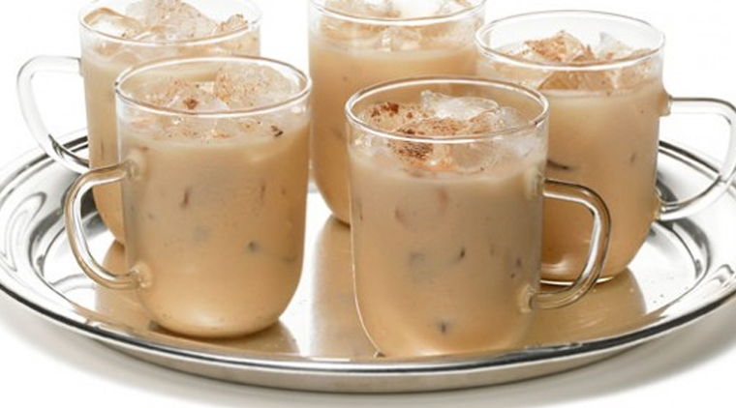

A nice refreshing 'chill-out' drink over ice on a hot day! Guiness punch has a lovely 'rich' (as Caribbean folks would say), full flavour, that moves smoothly over the tongue.

An easy one to make - all you need are the ingredients and a jug!

**INGREDIENTS**

1 bottle or can of Guinness

3 scoops ice-cream or 1 can of vanilla Supligen/Nourishment

½ cup of condense milk (some folks use a small tin)

1/2 tsp nutmeg

1 tsp cinnamon

1 tsp vanilla

*(add more spices if desired, to your preferred taste)*

2 cups crushed ice (optional)

**METHOD**

1. Add Guinness, ice-cream (or Supligen/Nourishment), and condense milk in a

jug and mix well to combine.

1. Add nutmeg, cinnamon, and vanilla, and stir lightly.
2. Add crushed ice or place in a refrigerator to chill.
3. Serve cold and enjoy!